**A**

**Project Report**

**On**

**"Jupiter Protocol, Video Call Web, WhatsFolio App”**

**Prepared by**

Yatharth Chauhan (20DCE019)

**Under the**

**guidance**

**of**

Ms.

Sachi Joshi

A

Report

Submitted to

Charotar University of Science and Technology

F

or

Partial

Fulfillment

of the Requirements for the

5

th

Sem

ester

Summer Internship-1 (CE346)

**Submitted at**

**Department of Computer**

**Engineering**

**Devang Patel Institute of Advance Technology and Research**

**At:**

**Changa**

**,**

**Dist: Anand**

**–**

**388421**

**Ju**

**ly**

**2022**





**CERTIFICATE**

This is to certify that the report entitled “UI-UX Design” is a bonafied work carried out by **Mr. Yatharth Chauhan (20DCE019)** under the guidance and supervision of **Ms. Sachi Joshi** for the subject (CE346)- **Summer Internship-I** (CE) of 5th Semester of Bachelor of Technology in **DEPSTAR** at Faculty of Technology & Engineering – CHARUSAT, Gujarat.

To the best of my knowledge and belief, this work embodies the work of candidate himself, has duly been completed, and fulfills the requirement of the ordinance relating to the B.Tech. Degree of the University and is up to the standard in respect of content, presentation and language for being referred to the examiner.

|  |  |
| --- | --- |
| Ms. Sachi Joshi  Assistant Professor  Computer Engineering(CE)  DEPSTAR, Changa, Gujarat. | Mr. Dharmik Kotak  HR  DTech Studio  Junagadh, Gujarat. |
| Dr. Dweepna Garg  Head of Department - Computer  Engineering, DEPSTAR CHARUSAT, Changa, Gujarat. | Dr. Amit Ganatra Principal, DEPSTAR Dean, FTE  CHARUSAT, Changa, Gujarat. |

**Devang Patel Institute of Advance Technology And Research At: Changa, Ta. Petlad,**

**Dist. Anand, PIN: 388 421. Gujarat**

20DCE019 CERTIFICATE

**INTERNSHIP COMPLETION CERTIFICATE**

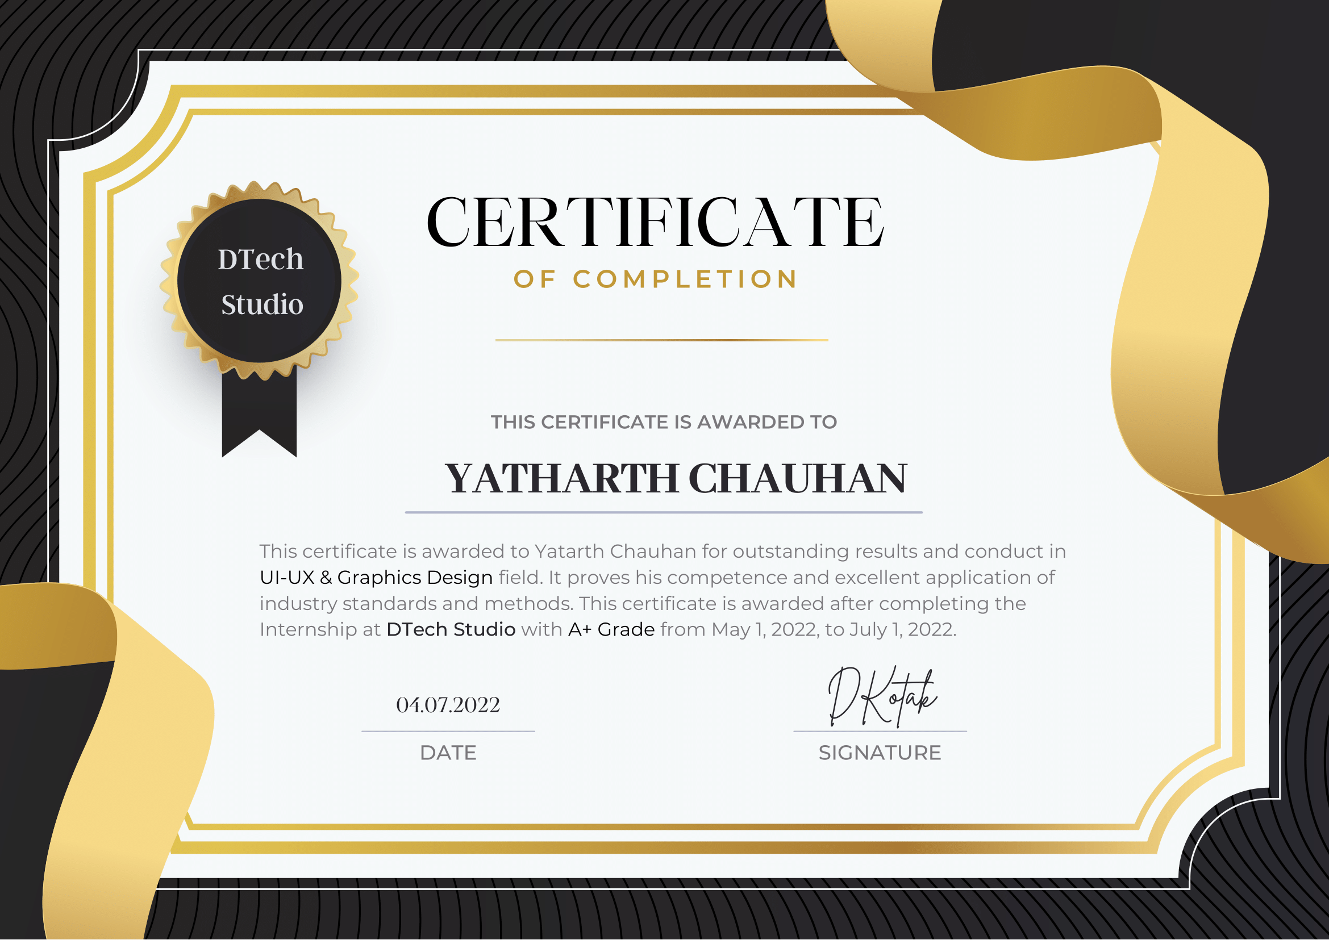

20DCE019 ACKNOWLEDGEMENT

**ACKNOWLEDGEMENT**

I am grateful to Mr. Dharmik Kotak, HR (D. Tech Studio) for giving me this opportunity to work the guidance of renowned people of the field of MIS Based Portal also providing me with the required resources in the company.

I would like to express my endless thanks to my external guide Mr. Dharmik Kotak & Mr. Muhammad Atik at D. Tech Studio for their sincere and dedicated guidance throughout the Internship.

Also, my hearty gratitude to our Head of Department, Dr. Dweepna Garg and my internal guide Ms. Sachi Joshi for giving us encouragement and technical support on the project.

Yatharth Chauhan

Student ID: 20DCE019

20DCE019 ABSTRACT

**ABSTRACT**

Summer Internship/Training is an integral part of the BTech(CE) program. The objective of such an exercise is to get a first-hand exposure to the realities of the CE segment and gain an insight into the working of the corporate world and develop technical and communicational skills. The summer training gives an opportunity to become aware of the student’s strengths and weakness as required for potential design experts.

“UI/UX” is a designing skill. For that I have designed and redesigned many live projects like Jupiter protocol (mobile application & website), Zero pay home page and portfolio dashboard design, M chat (was basically video call and chat board website), ZNS logo designs, NASA industry Go green project redesigning. There were many other projects too, Moon exchange dashboard design, HR management user personas. This all were designed by me using Figma and Illustrator tools.

This internship lent me to showcase my skills and training of the concepts and technologies in a professional manner. Through this internship I got an opportunity to be in a team and to enhance communicational skills and to collaborate and connect with different ideas and brains.

20DCE019 DECLARATION BY THE CANDIDATE

**DECLARATION BY THE CANDIDATE**

I hereby declare that the project report entitled **“Jupiter Protocol, Video Call Web, WhatsFolio App”** submitted by me to DTech Studio in partial fullyfillment of the requirement for completed the summer internship, carried out by me under the guidance of **Mr. Dharmik Kotak**.

I further declare that the work carried out and documented in this project report has not been submitted anywhere else either in part or in full and it is the original work, for the award of any other degree or diploma in other institute or university.

20DCE019 TABLE OF CONTENT

**TABLE OF CONTENT**

|  |  |
| --- | --- |
| Certificate | i |
| Internship Completion Certificate | ii |
| Acknowledgement | iii |
| Abstract | iv |
| Declaration By Candidate | v |
| Table Of Content | vi |
| Table Of Figures | vii |
| Chapter-1: Introduction | 1 |
| Chapter-2: Project Definition | 1 |
| Chapter-3: Software and Hardware Requirements | 2 |
| Chapter-4: Screenshots of Projects | 3 |
| Chapter-5: Conclusion | 20 |
| Chapter-6: References | 21 |

20DCE019 TABLE OF FIGURES

**TABLE OF FIGURES**

|  |  |
| --- | --- |
| **FIGURE TITLE** | **PAGE NO.** |
| Fig: 4.1.1-Home Page | 15 |
| Fig: 4.1.2- A Brave New World | 15 |
| Fig: 4.1.3-About Jupiter Protocol | 16 |
| Fig: 4.1.4-Field of Jupiter Protocol | 17 |
| Fig: 4.1.5-Footer | 17 |
| Fig: 4.2.1-Home Page | 18 |
| Fig: 4.2.2-Running Video Call-1 | 18 |
| Fig: 4.2.2-Running Video Call-2 | 19 |
| Fig :4.2.2-Running Video Call-3 | 19 |
| Fig: 4.2.2-Video Call Full Screen | 20 |
| Fig :4.3.1-WhatsFolio Sign Up Page | 20 |

20DCE019 INTRODUCTION

**CHAPTER** **1: INTRODUCTION: UI-UX DESIGN**

|  |
| --- |
| **What is UI Design?**  User interface (UI) design is the process of designing the look, feel, and interactivity of a digital product.  **What is user interface (UI) design?**  A user interface is the point of interaction between humans and computers. User interface design is the process of designing how these interfaces look and behave.  Imagine you’re using an app on your smartphone to book flights. The screens you navigate, the buttons you tap and the forms you fill out are all part of the user interface.  **What is the difference between UX and UI?**  UI design relates to the appearance and feel of a digital product. It focuses on visual factors like buttons, fonts, colour schemes, images, interactive elements, etc.  So, what is user experience design, then? Well, it refers to the experience a user has interacting with your product. Its main focus is enabling seamless goal achievement for users.  20DCE019 INTRODUCTION  **An introduction to UI design tools and software:**  UI designers use various tools and software to help them create delightful, interactive interfaces. Some of the most popular UI design tools include:  **Figma:** A web-based interface design tool built for fast and collaborative design. Figma is a vector graphics editor that will take you from early-stage ideation through to interactive prototyping.  **Adobe XD**: Another all-encompassing vector-based UI tool, Adobe XD is used for early ideation and low-fidelity designs, right through to animations and high-fidelity, interactive prototypes.  **Sketch:** A vector graphics editor used for drawing, wireframing, prototyping and design handoff. Sketch is considered an industry-standard design tool, used by both UX and UI designers. |

20DCE019PROJECT DEFINITION

**CHAPTER** **2:** **PROJECT** **DEFINITION**

|  |
| --- |
| * 1. **Jupiter protocol:** * It was the website that gives the information of Jupiter planet. That come to this planet and gives many more information of Jupiter protocol. * Motive: Lend, borrow and earn with an autonomous credit protocol in the Cosmos universe. Open to all, closed to none. * Jupiter is a credit protocol for the future: non-custodial, open-sourced, transparent, algorithmic, and community-governed.   **Jupiter has three primary components:**   * The Red Bank: Where users can lend and borrow assets (this is also known as collateralized borrowing). * The Fields of Mars: Where users can interact with applications built on top of the Red Bank such as leveraged yield farming (this is also known as contract-based borrowing). * The Martian Council: Where users with staked Jupiter can propose and vote on changes to the protocol. |

**2.2** **M chat video calling project:**

* This website was mainly designed for video calling and for chat. I designed so many variations in different scenarios.
* User can chats with one person during video call and add participants in a video call and also do group video call and chats with them.
* In this video call web, add a friend, Create a new group and add friends and also add friends in existing group.

**2.3 WhatsFolio App UI:**

* A Business service providing app project. I Designed attractive sign up, login and password changed page.
* This is a one business portfolio making app. Here, I design starting page of registration page with trending effect glass morphism effect.

20DCE019 SOFTWARE & HARDWARE REQUIREMENTS

**CHEPTER 3: Software and Hardware Requirements**

This all were made using the following.

**Software Requirements:**

* Figma
* Illustrator
* Adobe XD

**Hardware Requirements:**

* 2 GB RAM
* 1 GB HDD
* Windows 7, 8. 10, 11 any operating system

20DCE019 SCREENSHOTS OF PROJECTS

**CHAPTER** **4:** **SCREENSHOTS OF PROJECT**

**4.1 Jupiter protocol:**

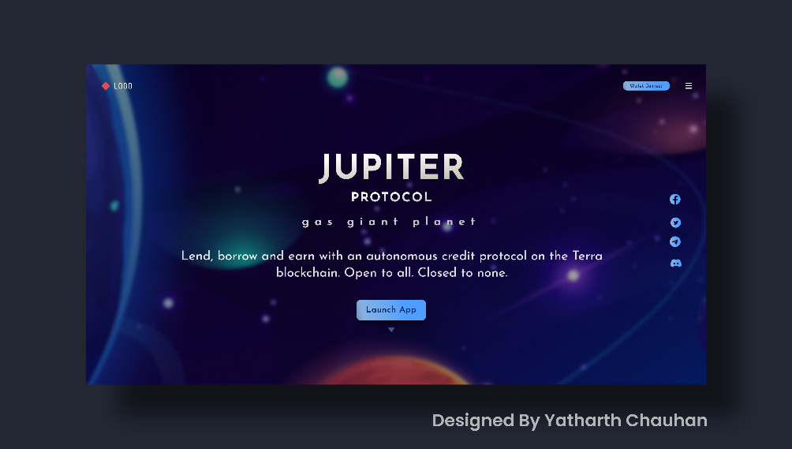

Fig:4.1.1-Home Page

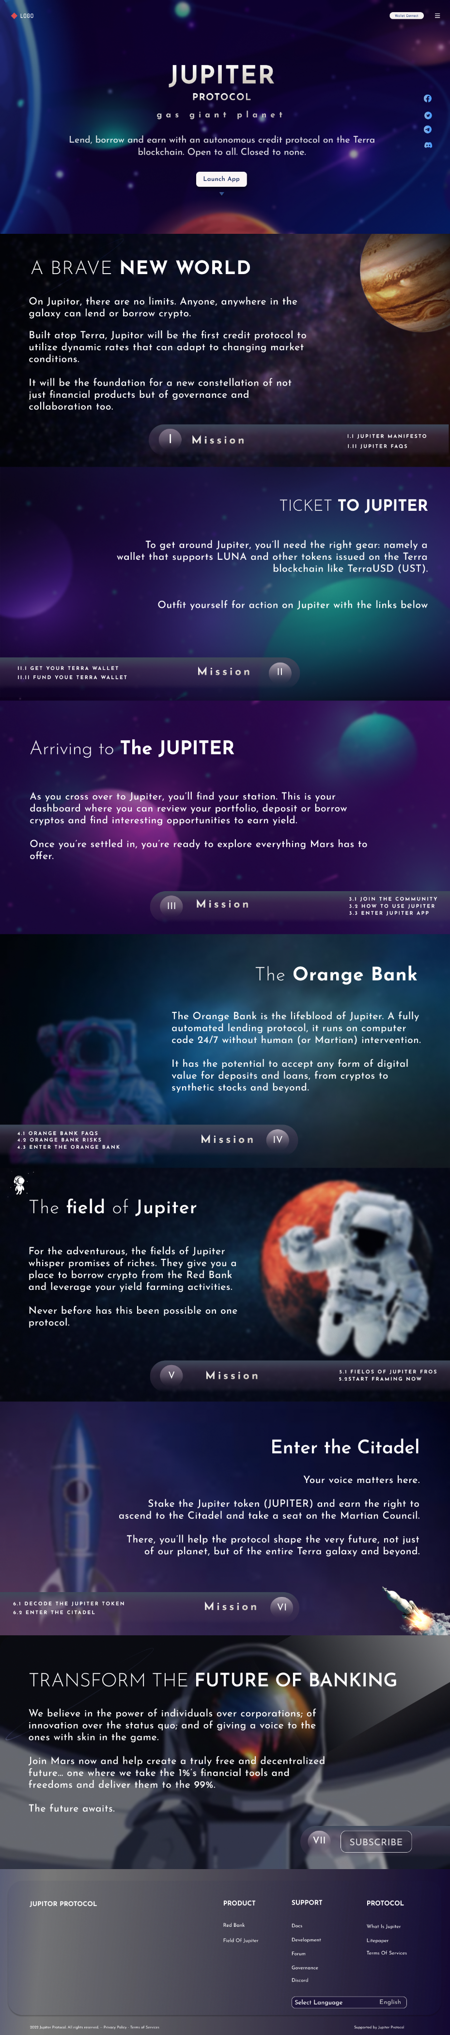

Fig:4.2- A Brave New World

20DCE019 SCREENSHOTS OF PROJECTS

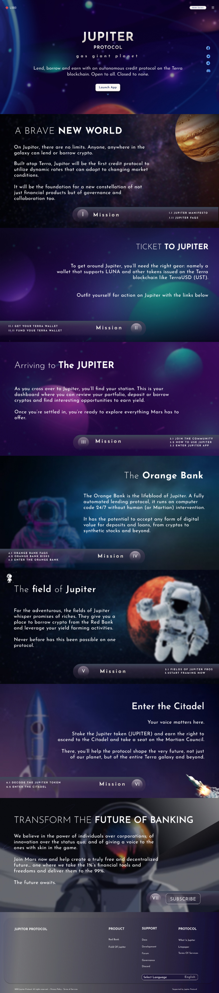

Fig:4.1.3 About Jupiter Protocol

20DCE019 SCREENSHOTS OF PROJECTS

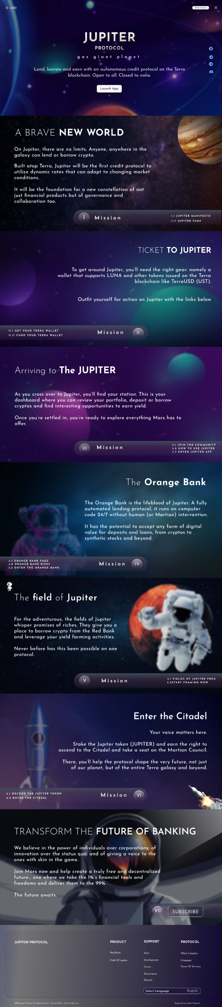

Fig:4.1.4 Field of Jupiter Protocol

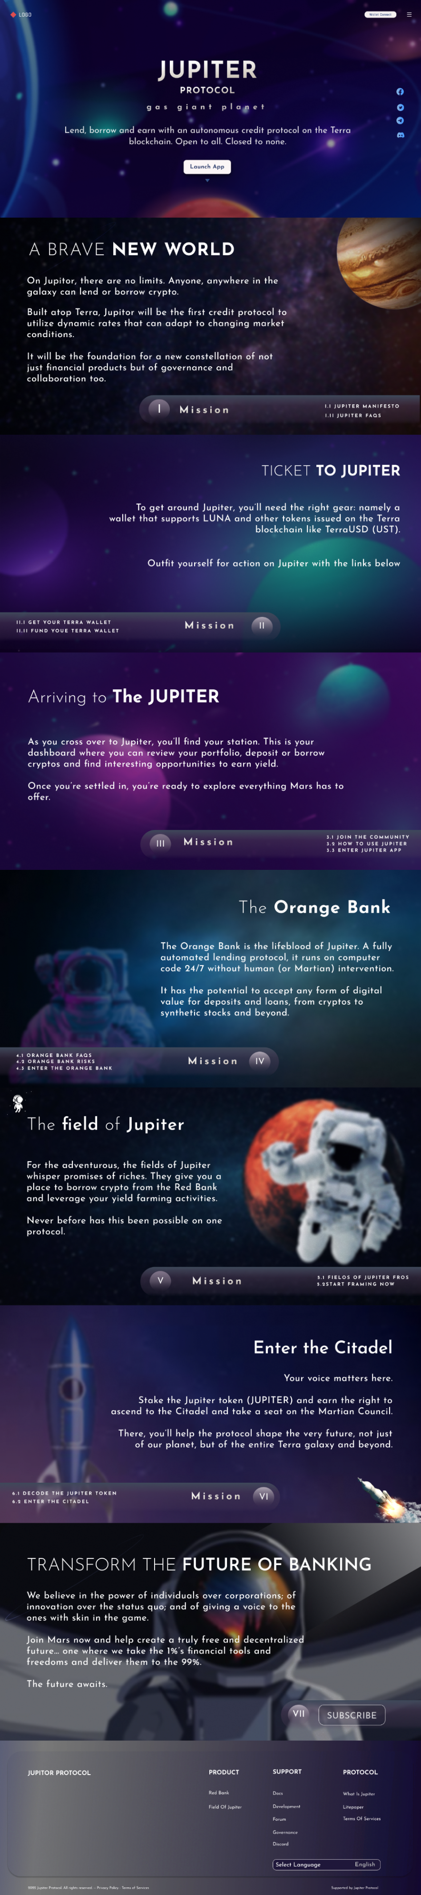

Fig:4.1.5- Footer

20DCE019 SCREENSHOTS OF PROJECTS

**3.2 M Chat Video Call Web Design**

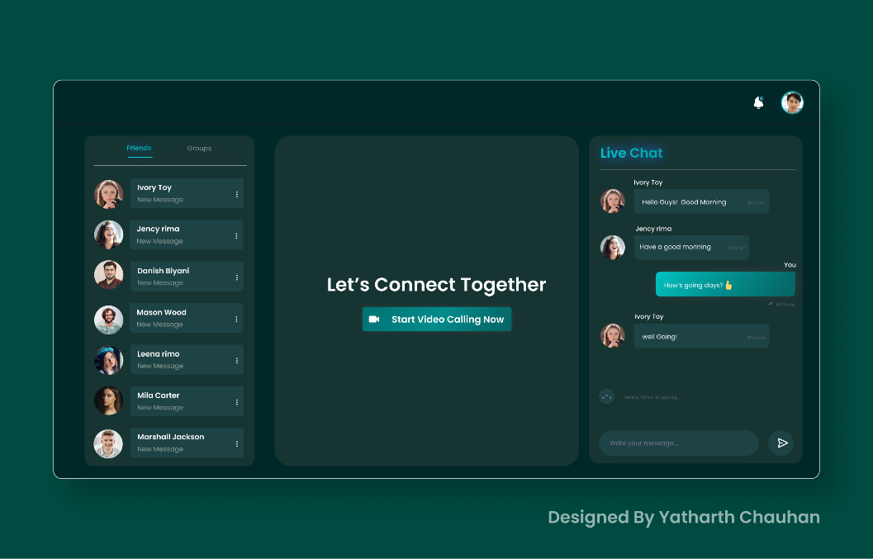

Fig:4.2.1-Home Page

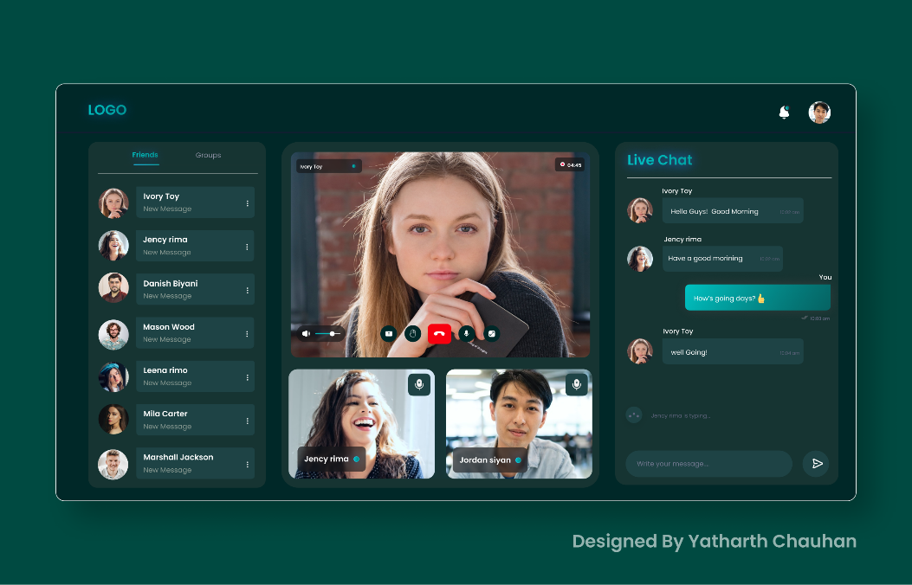

Fig:4.2.2 -Running Video Call-1

20DCE019 SCREENSHOTS OF PROJECTS

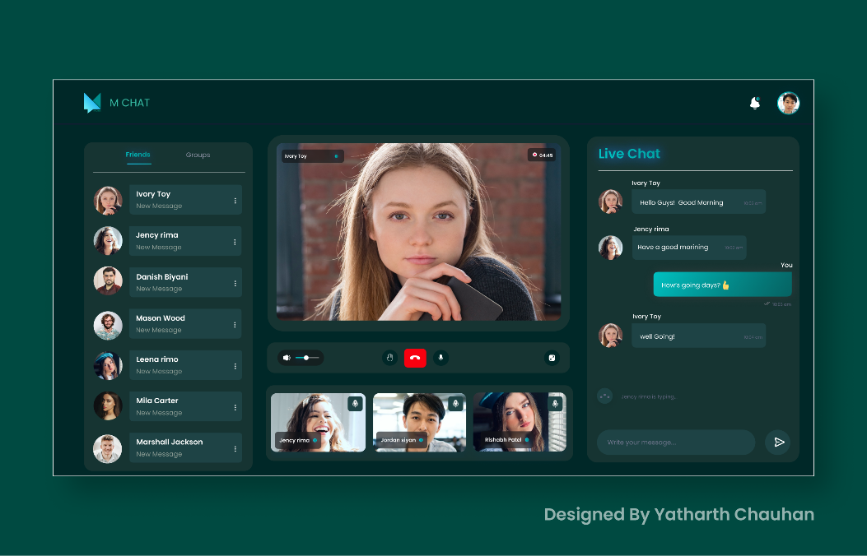

Fig:4.2.3-Running Video Call-2

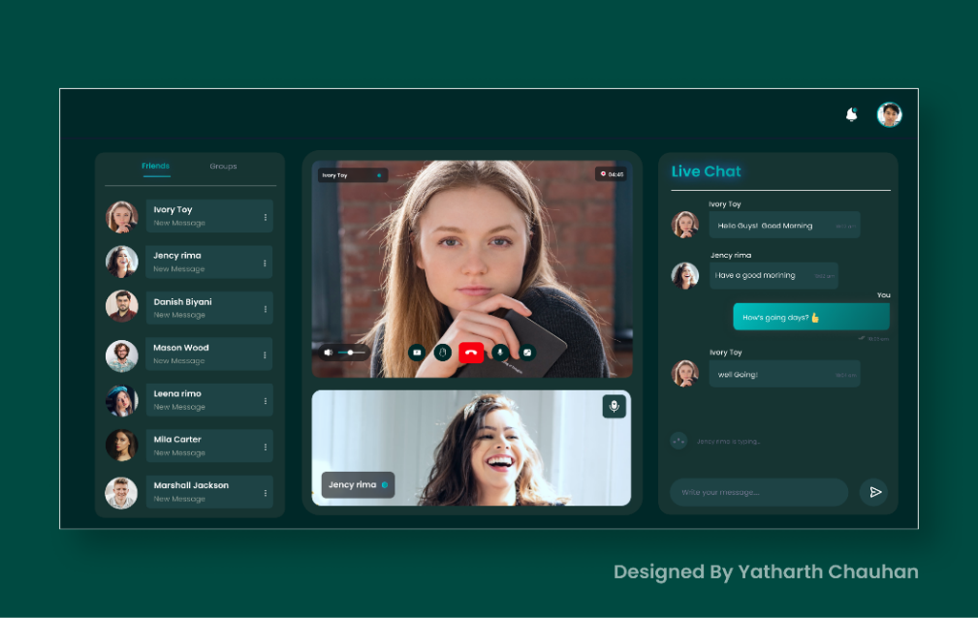

Fig:4.2.4-Running Video Call-3

20DCE019 SCREENSHOTS OF PROJECTS

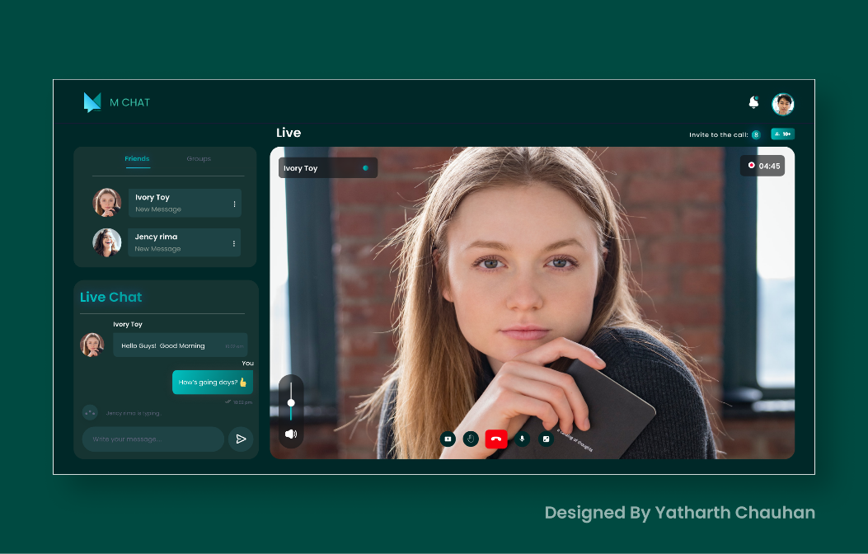

Fig:4.2.5-Running Video Call Full Screen

**4.3 WhatsFolio Logo**

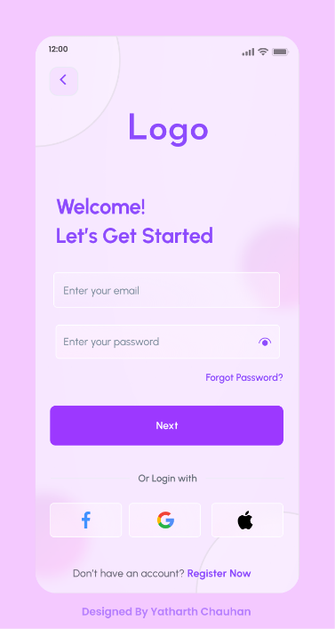

Fig:4.3.1-WhatsFolio Sign Up Page

20DCE019 CONCLUSION

**CHEPTER 5: CONCLUSION**

* The main benefits of this project is this is live project So I am understand how the industry is work on different parameters.
* I am UI-UX & Graphic Design role in live project so we are understanding how to work in team, how to design a UI of a client requirements , and how maintain graphics in project.
* Also learn how to communicate with team through clients meeting and understood what is the need of industries.
* In this internship I am facing many issue in starting week but after that all are settled very well and I am understand how to design.

20DCE019 REFRENCES

**CHEPTER 6: REFERENCES**

1. <https://marsprotocol.io/>
2. <https://dribbble.com/shots/14098679--Srawung-Video-call-app-to-connecting-people>
3. <https://dribbble.com/shots/14098679--Srawung-Video-call-app-to-connecting-people>
4. <https://dribbble.com/shots/15050094-Called-Video-Call-App>
5. <https://dribbble.com/shots/15889044-Login-Register-Mobile-App>